Institute of Computer Technology

B. Tech Computer Science and Engineering

Subject: Computer Organization (2CSE205)

**PRACTICAL-10**

**AIM: - Computer motherboard and its parts.**

There are primarily two types of motherboards, AT motherboard, and ATX motherboard.

A motherboard is given below: -

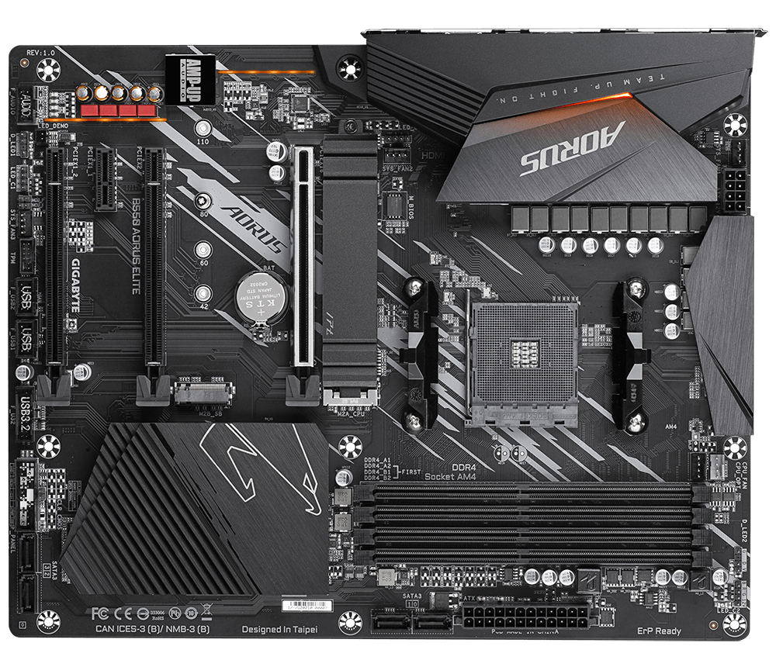

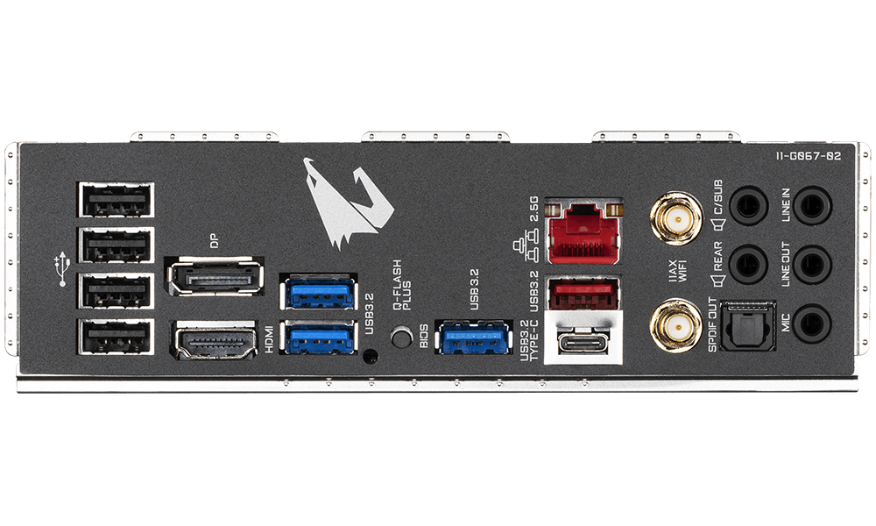

1. **CPU Socket: -** Here we have to insert our processor.



1. **RAM Slots: -** Here we insert our memory/RAMs.



1. **ATX 24-pin connector: -** Here we have to connect the 24-pin connector from SMPS to give power to motherboard.



1. **CPU Fan connector: -** In this port we have to connect the cable of CPU fan.



1. **SATA connectors: -** Here we connect the SATA connectors of hard disks and cd drives.



1. **USB Connectors: -** Here we connect the USB connectors from the case of cpu.



1. **PCle Slots: -** Here we connect our graphics card / lan drivers / display capture cards, etc.



1. **I/O Ports: -** There are several ports on the I/O panel of motherboard. They are****

**Audio I/O Connectors (mic,speakers)**

**Wifi Connector**

**Ethernet LAN Port**

**Display Port and HDMI**

**USB Ports**

**USB Ports**

**USB Ports**